Tools and Technologies

Our project will be requiring several technologies, tools, and resources to accomplish our project goal. These will be hosted virtual servers, devices for testing our application, software packages, software development kits, and application programming interface documentation.

Virtual Servers

Virtual servers will be used for the backend applications that will be processing the user’s Security, Privacy and Sharing Settings using a combination of API calls and web scraping that will be too complex for a mobile device to accomplish with any real speed.

Some of these will be used as webservers to host various tutorial videos and support pages, we have chosen to use NGINX as our webserver software due to its ability to serve larger visitor numbers than Apache2.

A combination of PostgreSQL and MongoDB database servers will be used by both webpage content and backend application data storage.

AWS will also be used for end point delivery to the mobile application and for inbound feeds from the social media platforms to avoid security protection systems in place that may block our access as suspicious activity due to the high volume of traffic.

Devices & Testing Platforms

To adequately test our application, we will need access to both a compatible Android device and a compatible Apple device. However, in the early stages of development we can use the development environment SDKs virtual machines to test the basic functionality and review the design of the application.

Development Environment

Android Application - Android Studio will be used to build the mobile application for android devices using the publicly available Android SDK, this software is available on Windows, Mac, Linux, and Chrome OS.

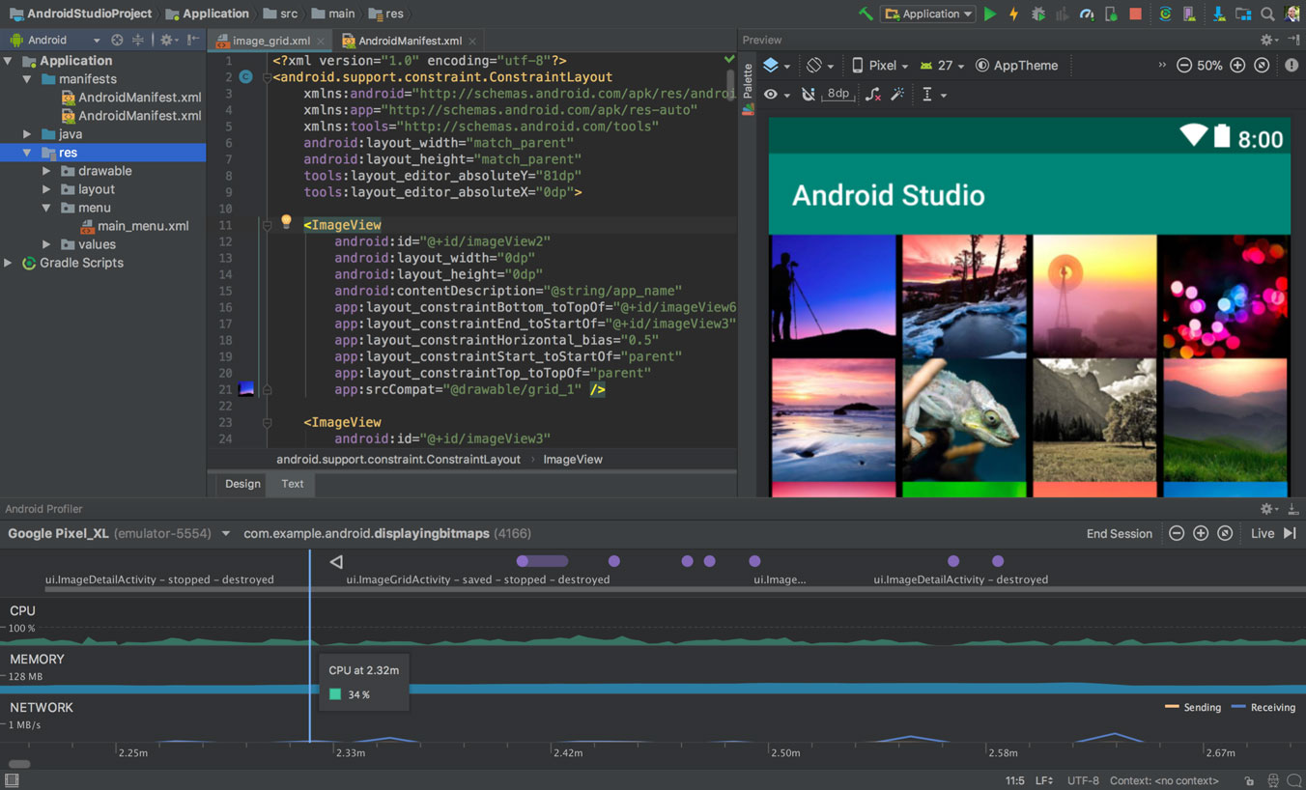

Figure 1: Andriod Studio UI, Source: <https://developer.android.com/studio>

iOS Application – Apple XCode and iOS SDK will be required to build an iOS application, unfortunately this is only available on Mac, to get around the hassle of requiring an apple computer we will build a virtual machine running MacOS. This is called a Hackintosh.

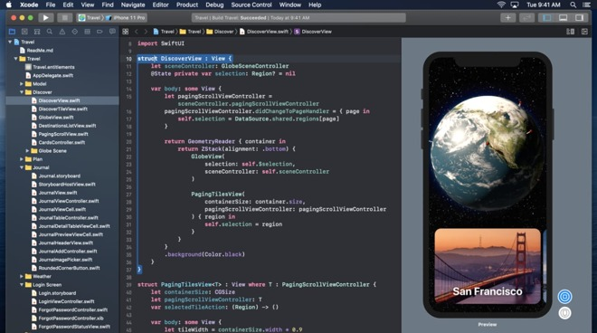

Figure 2: Apple XCode UI, Source: https://appleinsider.com

Facebook Platform – to access all the features of the Facebook API and SDK we will need a Facebook developer account which is subject to approval and has a complicated and lengthy process.

Code Repository – All code will be checked into private repository’s on GitHub, they will be private to prevent public access to our source code which may benefit a competitor, hackers, or make it easier for social media platforms to prevent us running our various checks.

Backend Development – a combination of PHP, JAVA and Python will be used to create the various Security, Privacy and Sharing Setting checks, as parts of these checks will be easier to accomplish using different programming languages and will allow us to use a lot of prebuilt software tools.

Tutorial Video Environment

Open Broadcast Studio, will be used to record our tutorial videos as it allows us to screen capture, and record audio, Adobe Premiere will then be used to edit the footage and insert various extra footage that may be required in the tutorial.

Daniel notes / draft / brainstorm space (working on with Channon and Adam)

\*Daniel - reading A2 feedback - starting work now - will have something for review by meeting 4 - hopefully

From Spec:

*What software or other tools are required by the project?*

Figma for User Interface design mockup

Office 365 - Teams, Word

Microsoft Project check with Maddie

Presentation Software - off Channon, Sam, Maddie

App dev off Adam

*Are there any software licenses needed?*

Using Freeware / Open source and Student license

Will we need to purchase any?

*Is there any hardware needed (beyond a standard laptop or something similar)?*

*This needs to be precise (e.g. Windows Movie Maker Version 45.3) but needn't be long.*

*You should also include a brief description of any prior experience any group members have had with the tools and technologies you list.*

*There is no minimum length for this.*

*It is important to be as precise as possible, but descriptions of the tools are not needed here.*

[2:36 PM] Channon Harper

Daniel Scarfe think this is your section right? just so you know tools using for presentation

Gimp 2.10.22 - image creation (open source photoshop) used for removing backgrounds and making multi layer images used this for logos, character cutting & creation

OpenToonz 1.4 feb 2 build(open source) - used for scene creation where can manipulate multiple layers frame by frame and add skeletons for animations.

ShotCut 20.10.31 (open source) - cuts scenes and audio together to make the end presentation can use multiple audio tracks and has many features to manipulate video and audio

Windows voice recorder - used for sound bytes was using something else but was having some mic issues

Paint 3d - used to make some text images as has a easier interface than gimp imported into gimp after creation

Dont know if needed but also used Graphical Tablet for easier image creation

​

[3:38 PM] Daniel Scarfe

Cool, thanks for that Channon. I'll note those down in software and hardware needed.

Could you let me know if any of those software needs a license or if any are freeware/open source as one of the questions in the Tools and Tech section is "Are there any software licenses needed?"- cheers.